Maven

Introducing Apache Maven

Installing Maven

Maven repositories – Local, Central, Remote

Build profiles, Running Maven Project, Maven Configuration

The Project Object Model

The Build Lifecycle

Creation of Maven Project

**Steps to create a Maven Project in ECLIPSE**

1. **Click on File**

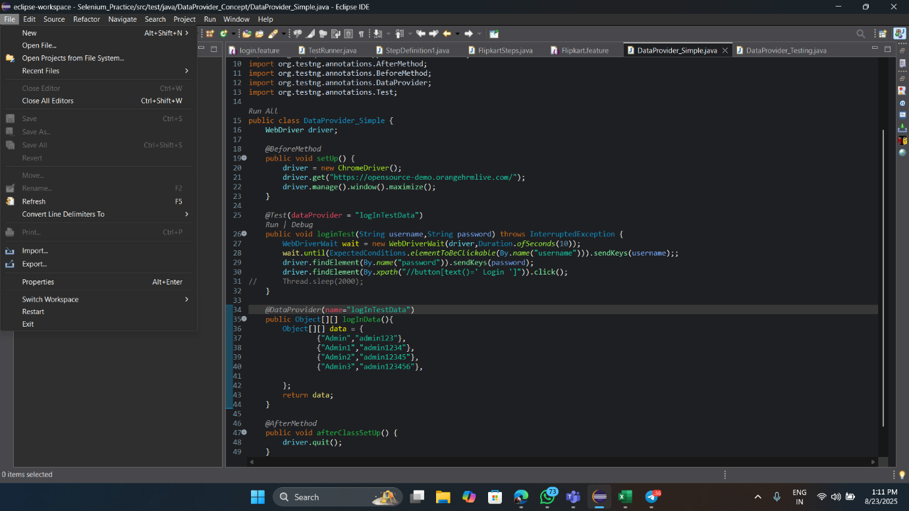

1. **Click on New and then on Maven Project**

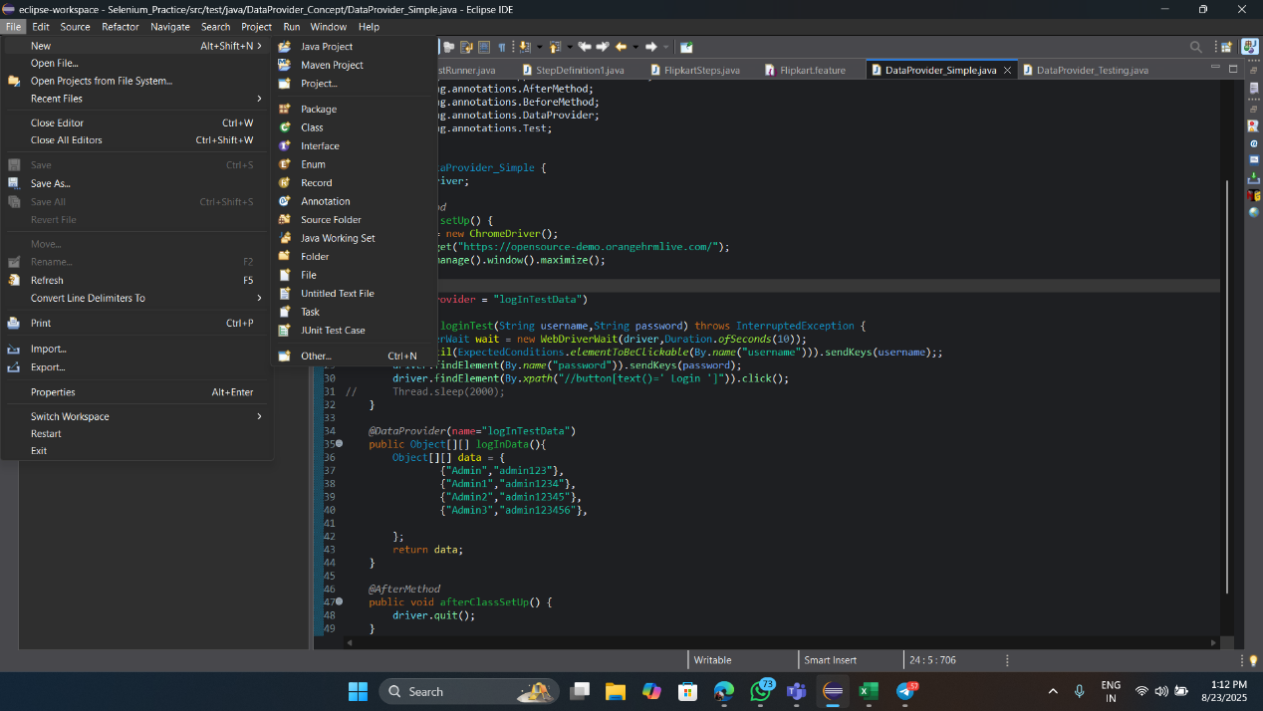

1. **Click on next**

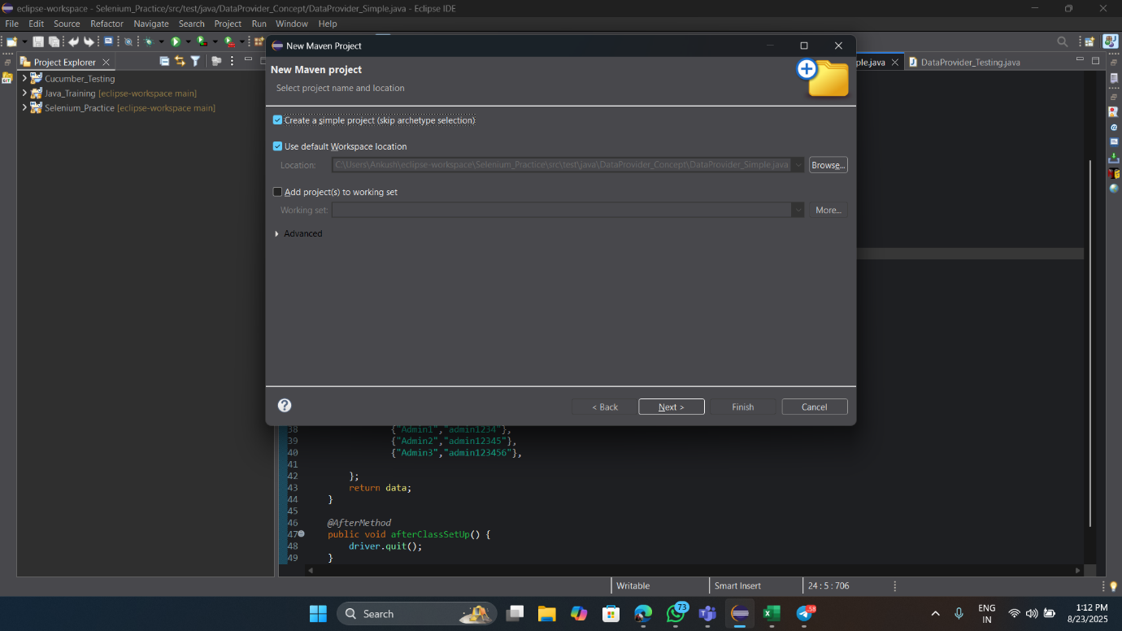

1. **Write Group ID and Artifact ID and then click on Finish**

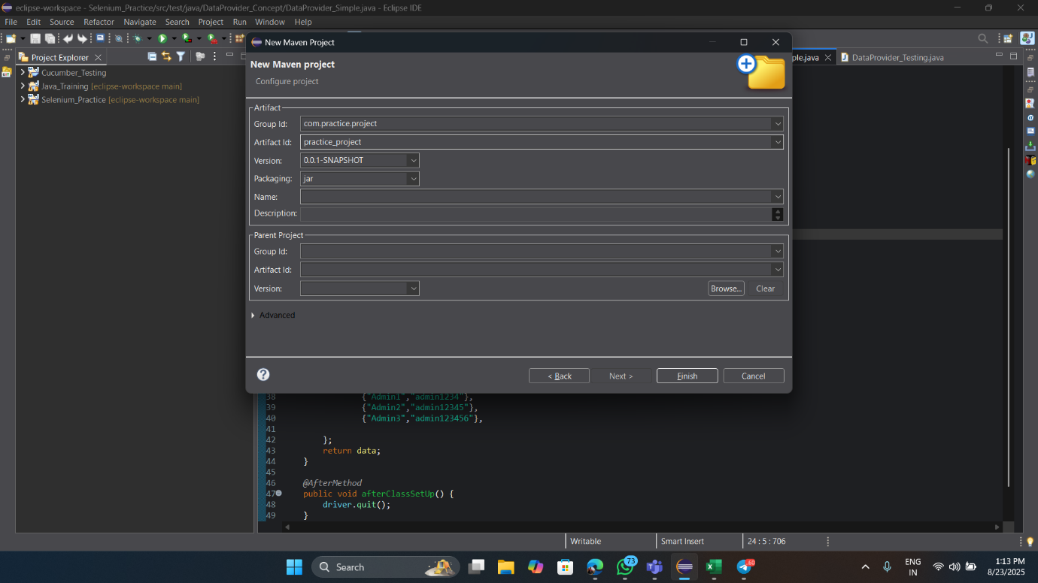

This is how we can create a Maven Project in eclipse and after creating a maven project a predefined folder structure will be showed in project explorer of Eclipse that consists multiple important folders and files and we need to work on that file.

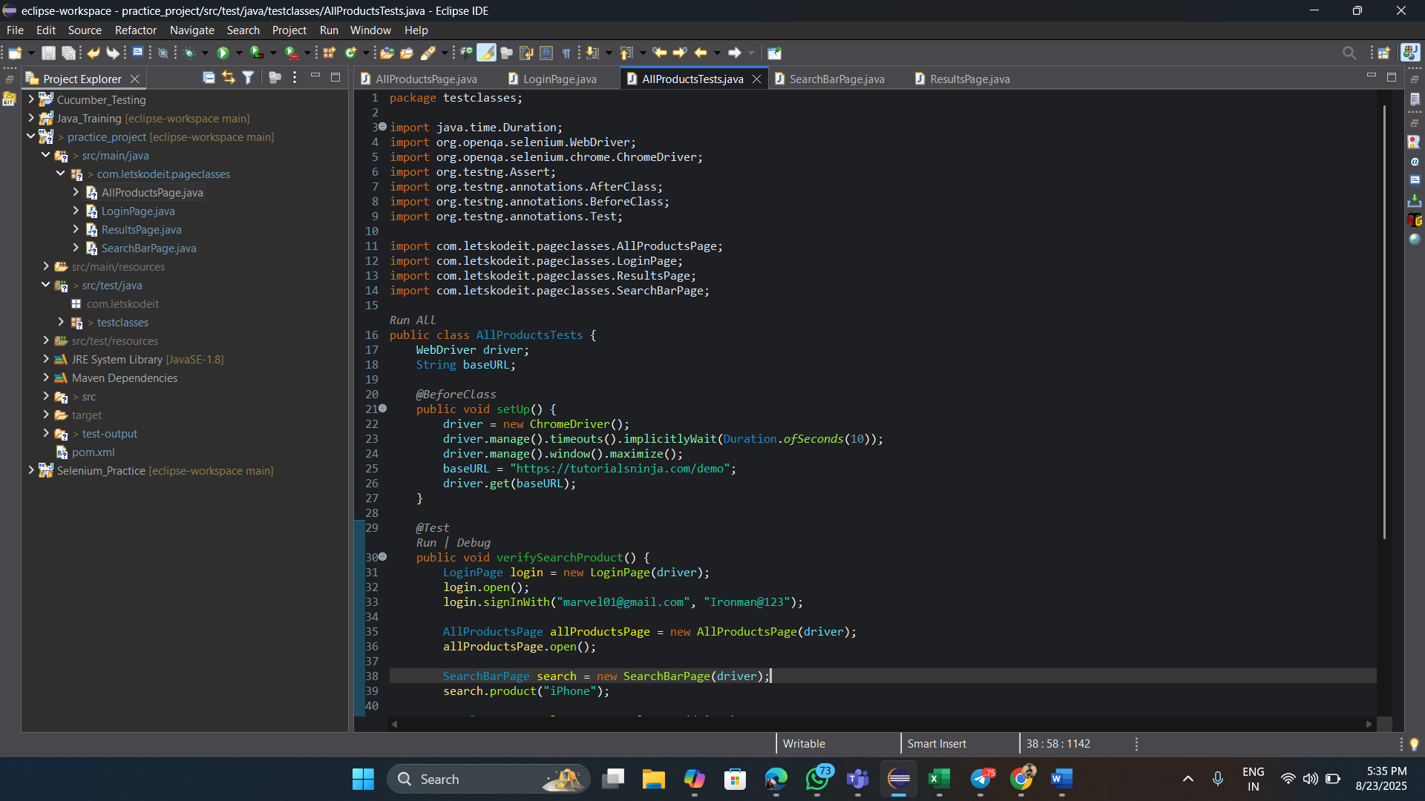



**Project object Model:** pom.xml

Pom.xml file contains important dependencies and also, we need to write dependencies based on requirements from maven repositories.

